**Does It Have To Be a 12-Week Proof of Concept (POC) Study? Prediction of Week 12 Efficacy from Short-Term HbA1c Treatment Effect using Model-Based Meta-Analysis of Literature Data**

Jing Liu1,*, Rebecca Boyd1, Jaap Mandema2

1 Clinical Pharmacology, Pfizer, Groton, CT; 2 Quantitative Solutions, Menlo Park, CA

**Objectives**: To evaluate the predictability of HbA1c treatment effect at Week 12 from Week 4 HbA1c response using summary-level data from the literature and a MBMA, to aid in the interpretation of short-term study results and to potentially provide justification for shorter POC studies in drug development for T2DM.

**Methods**: A database of study-level aggregate data from published clinical trials in T2DM was constructed by Quantitative Solutions (Version: April 20, 2014). From this database, a total of 119 trials with 29 drugs in 12 drug classes containing both Week 4 and Week 12 HbA1c data were selected for modeling. HbA1c(%) difference from control at Week 12 (DFC12) was described by a mixed-effect linear function of HbA1c(%) difference from control at Week 4 (DFC4): DFC12,ij =E0+(SLP+ETAi)*DFC4,ij, in which E0 is the intercept, SLP is the typical slope, ETA is the additive inter-trial random effect. The variance was fixed to the inverse standard error squared of each trial (i) and study arm (j). The final model was evaluated using a predictive check of selected sitagliptin trials. R2.15.2 and S-PLUS 8.0 were used for data processing and modeling, respectively.

**Results**: Across all 29 anti-diabetic drugs, except for thiazolidinediones, with known slow onset, HbA1c(%) DFC12 was described by a single linear function of DFC4, with SLP of 2.00[1.88-2.12], E0 of 0.033[0.008-0.058], and inter-trial variability on the SLP of 23%[19%-28%], (mean[90% C.I.]). The predictive check suggested that the model adequately predicted the observed HbA1c treatment effects of sitagliptin at Week 12 in similar populations across multiple trials (Figure 1).

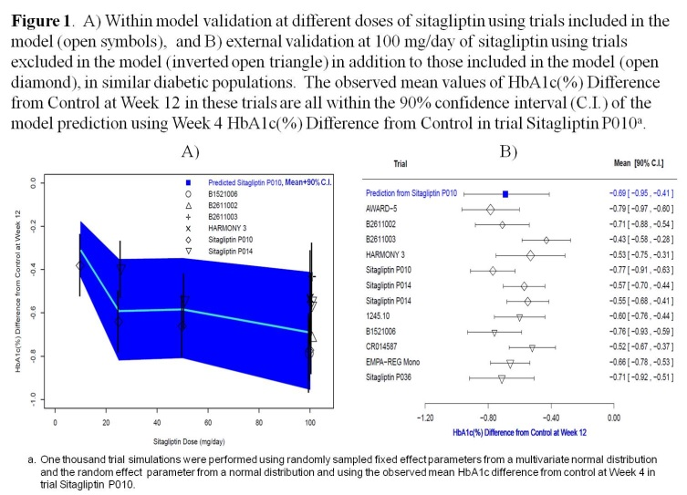

**Conclusions**: The HbA1c treatment effect at Week 12 is predicted to be 2-fold greater than the effect at Week 4 in a similar population, with 23% inter-trial variability using the direct linear MBMA model. Additional characterization of inter-trial variability and potential prediction across populations and at different time-points is being further evaluated using MBMA of longitudinal data.

**References**:

[1] Mandema J, et al. Diabetes. 61(suppl. 1): A1015, 2012